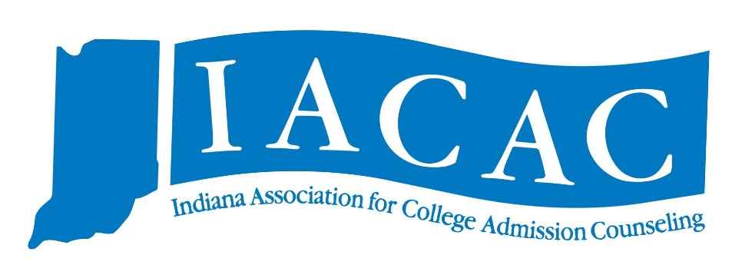
The IACAC Professional Development Committee is excited to roll out a new initiative in the fall of 2019. IACAC Counselor Updates are a single-day event that provide high school counselors with updated information from various institutions and agencies. The day includes a wide variety of sessions and a Counselor College Fair. Our goal is to host a professional learning one-stop-shop, similar to what happens during an IACAC Conference. This event will cost $10 for high school counselors and offer PGP points. Two locations will be rolled out this fall with more to come in 2020. This year we are excited to host Counselor Updates at Valparaiso University on Monday, September 16 and IUPUI on Tuesday, September 17. Watch for more information as registration will open in July.

Monday, September 16th: Valparaiso University
Tuesday, September 17th: IUPUI
IACAC Counselor Updates (Tentative Schedule)
- 8:15 to 9:30 a.m.: Registration
- 9:30 a.m.: Welcome
- 9:50 to 10:25 a.m.: Indiana Department of Education (DOE) Updates
- 10:30 to 11:20 a.m.: Breakout sessions (pick one)
  - Public School Updates
  - ACT and/or College Board Updates
  - Financial Aid Overview
  - Campus Tour
- 11:25 to 12:15: Breakout sessions (pick one)
  - Private School Updates
  - ACT and/or College Board Updates
  - Visit Programs (High School and College Panel)
  - Campus Tour
- 12:15 to 1:15 p.m.: Lunch
- 1:30 to 2:30 p.m.: Counselor College Fair

(Please note that the schedule is subject to change. Registration will open in July with an official schedule for both locations posted at that time)

